Item | Rental Price Per Unit | # | Description
Candelabras
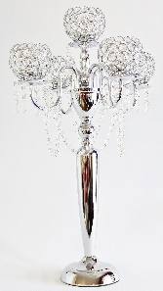 | $40 | 29 | Kylie  CGGC-26.5”  5 globe crystal gem candelabra with hanging crystals, includes votive cups  26.5” tall
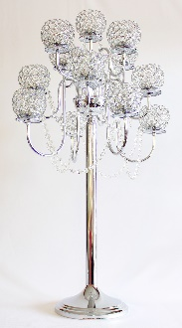 | $60 | 36 | Candice  CGGC-36.5”  13 globe crystal gem candelabra with hanging crystals, includes votive cups  36.5” tall
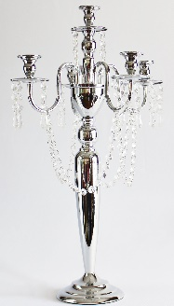 | $25 | 35 | Layla  C-SG-T  Candelabra with silver gems that hang tapered around centerpiece  24” tall without candles
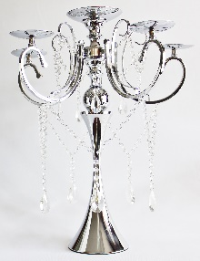 | $40 | 36 | The Great Gatsby  TGG-MSC-6C  Silver candelabra with 6 candle holders and hanging crystals  26.5” tall
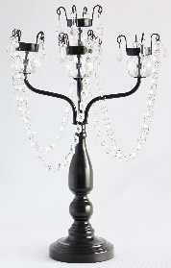 | $20 | 8 | Barbie  BCWPG-5T  Black candelabra with 5 tealight cups  and hanging gems  18” tall
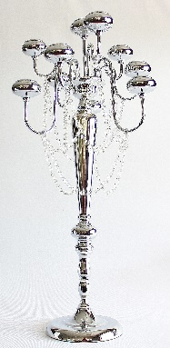 | $50 | 8 | Addison  TSFC  Tall silver candelabra with 10 tealight cups and hanging gems, includes votive cups  36” tall
Feather Centerpieces
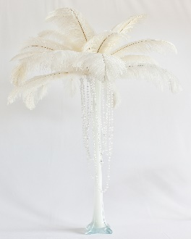 | $55 | 13 | Eiffel Tower  FC-ET  Eiffel tower vase with dangling gems, comes with 22 feathers per centerpiece  37” tall by 30” wide  **assembly of feathers required**
Candleholders
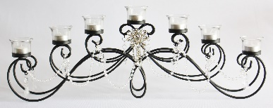  $12.50 |  | 1 | Sophia  HC-BS  Horizontal black scroll centerpiece with 7 tealight cups  9.75” tall, 27” wide
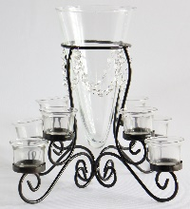 | $15 | 8 | Vivi  CV-V-VaseT  V vase with 8 tealight cups  12” tall
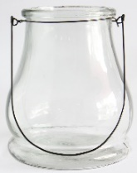 | $10 | 20 | Mia  CV-HGCS  Hurricane glass candleholder  10.25” tall
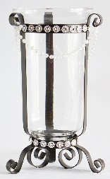 | $9 | 5 | Harper  CV-HCH  Hurricane candle holder with hanging gems  13” tall
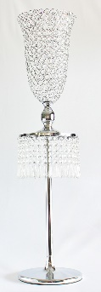 | $55 | 12 | Bella  CGC-39” T-RG  Wide tulip candleholder with raining gems  39” tall
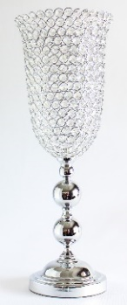 | $40 | 36 | Olivia  CGC-25”T  Tulip crystal gem candleholder  25” tall
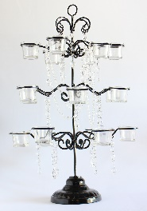 | $30 | 8 | Makenna  BC-18V  Black candleholder with 18 votives and hanging gems  24” tall
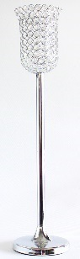 | $20 | 24 | Isabella  CGC-28”T  Tall tulip crystal gem candleholder  28” tall
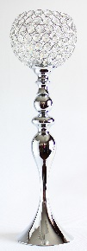 | $20 | 35 | Skylar  CGC-26”F (Tall)  Crystal gem fishbowl candleholder  26” tall
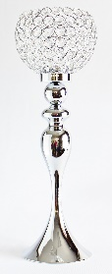 | $20 | 35 | Scarlett  CGC-24”F (Medium)  Crystal gem fishbowl candleholder  24” tall
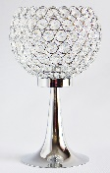 | $20 | 34 | Stella  CGC-14”F (Short)  Crystal gem fishbowl candleholder  14” tall
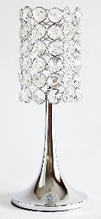 | $20 | 26 | Blaire  CGC-Lampshade style  Cylinder gem candleholder  17.25” tall
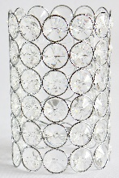 | $15 | 36 | Zoe  CGC-Cylinder  Cylinder crystal gem candleholder  8.25” tall
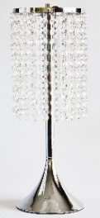 | $10 | 36 | Jade  RG-D  Raining gem candleholder  16” tall
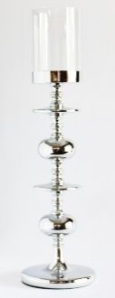 | $7.50 | 36 | Jasmine Halo (Tall)  SC-Modern17.5”  Modern silver candleholder with optional glass insert  22.5” tall with glass insert, 17.5” tall without glass insert
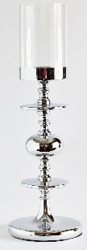 | $6.50 | 35 | Jasmine Halo (Short)  SC-Modern13.5”  Modern silver candleholder with optional glass insert 18.5” tall with glass insert, 13.5” tall without glass insert
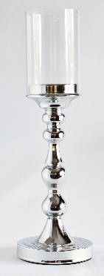 | $6 | 33 | Jasmine Globe (Tall)  SC-Rounded12.5”  Rounded silver candleholder with optional glass insert 17.5” tall with glass insert, 12.5” tall without glass insert
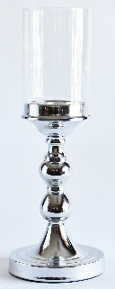 | $5.50 | 36 | Jasmine Globe (Short)  SC-Rounded9.5”  Rounded silver candleholder with optional glass insert 14.5” tall with glass insert, 9.5” tall without glass insert
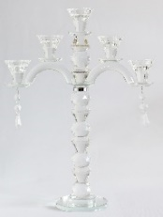 | $15 | 6 | Gemma  CTC  Crystal tapered candleholder  16.5” tall without candles
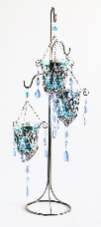 | $15 | 5 | Aubrey Blue  HGV-1  Colorful hanging candleholders with 3 votives each  24” tall
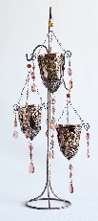 | $15 | 5 | Aubrey Brown  HGV-5  Colorful hanging candleholders with 3 votives each, 24” tall
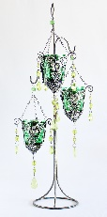 | $15 | 4 | Aubrey Green  HGV-2  Colorful hanging candleholders with 3 votives each  24” tall
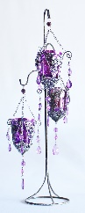 | $15 | 5 | Aubrey Purple  HGV-3  Colorful hanging candleholders with 3 votives each  24” tall
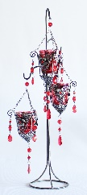 | $15 | 5 | Aubrey Red  HGV-4  Colorful hanging candleholders with 3 votives each  24” tall
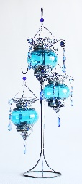 | $18 | 12 | Savannah Blue  HGB-1  Colorful hanging candleholders with 3 globes each  24” tall
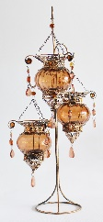 | $18 | 12 | Savannah Brown  HGB-5  Colorful hanging candleholders with 3 globes each  24” tall
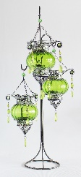 | $18 | 12 | Savannah Green  HGB-2  Colorful hanging candleholders with 3 globes each  24” tall
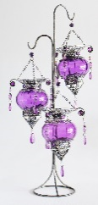 | $18 | 12 | Savannah Purple  HGB-3  Colorful hanging candleholders with 3 globes each  24” tall
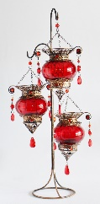 | $18 | 12 | Savannah Red  HGB-4  Colorful hanging candleholders with 3 globes each  24” tall
Table Additives
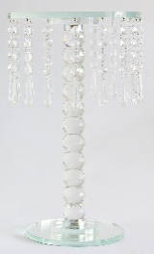 | $15 | 50 | Gracie  RG-15”CS  Clear raining gem riser/stand  15” tall
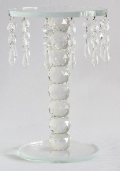 | $10 | 80 | Bailey  RG-10”CS  Clear raining gem riser/stand  10” tall
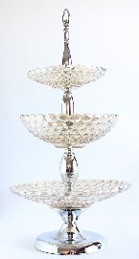 | $45 | 8 | Hazel  RBS-3 Bowls  Round stand with 3 bowls  27” tall
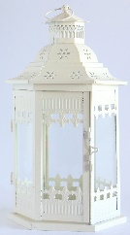 | $6 | 37 | Picket Fence Lantern  L-PFL  Six sided lantern, ivory colored, white picket fence style  12.5” tall
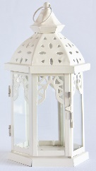 | $5 | 5 | Starburst Lantern  L-SL  Six sided lantern, ivory colored, lattice style 10” tall
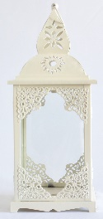 | $6 | 89 | The Barn Lantern  L-STC  Four sided lantern, ivory colored, oblong with lattice on corners  13.25” tall
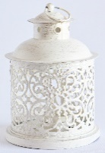 | $3 | 141 | Mini Cream Lantern  L-MCC  Short ivory round lantern with clover scroll design  6” tall
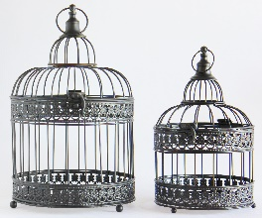 | $10 for set | 36 | Birdcages  BBC-2  Item comes 2 in a set, black  taller birdcage is 12.5“ tall and smaller birdcage is 10“ tall
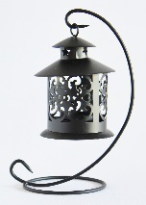 | $2 | 95 | Hanging Mini Lantern  L-8”HBT  Black hanging mini lantern  8“ tall
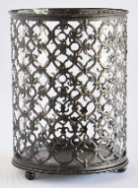 | $4 | 72 | Black scroll candleholder  PCH-RB  Black scroll candleholder with glass insert  5.5” tall
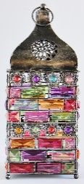 | $4 | 64 | Jeweled Lantern  MGC-L  Oblong square candleholder with multicolored jewels  10“ tall
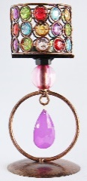 | $2 | 240 | Jeweled Tealight  MGC-TV  Circular tealight candleholder with multi-  colored jewels  7.5“ tall
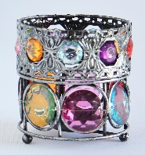 | $2 | 197 | Jeweled Cup  MGC-MV  Small circular candleholder with multicolored jewels  3.5“ tall
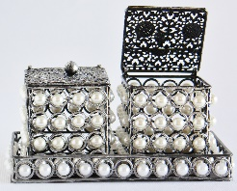 | $5 rent  $15 sale | 69 | Pearl Boxes  KB-P  2 pearl beaded boxes with pearl tray
Cake Stands
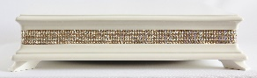 | $45 | 1 | Pearl White Cake Stand  CS-W  Pearl white square cake stand with bling edge, 17.75”x17.75”
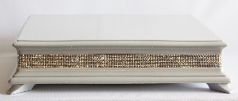 | $45 | 1 | Silver Cake Stand  CS-S  Silver square cake stand with bling edge, 17.75”x17.75”
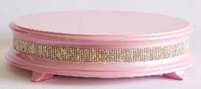 | $45 | 1 | Light Pink Cake Stand  CS-LP  Light pink circular cake stand with bling edge, 18” in diameter
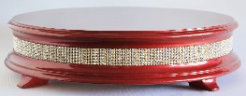 | $45 | 1 | Red Cake Stand  CS-R  Red circular cake stand with bling edge, 18” in diameter
Picture Frames
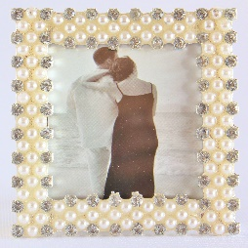 | Rent  $3  Sale  $15 | 60 | Ellie  PF-Ellie  Square pearl and rhinestone frame  2.5”x2.5”  photo
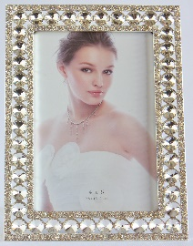 | Rent  $5  Sale  $35 | 60 | Paris  PF-Paris  Bling rhinestone rectangular frame  4”x6” photo
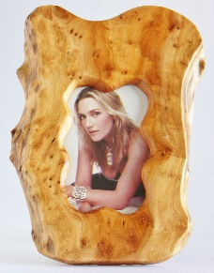 | $5 | 34 | Wood  PF-Wood  Wooden picture frame,  each a different shape  4”x6” photo
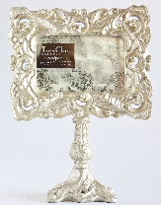 | $5 | 3 | Champaign pedestal picture frame with swirl designs  4”x6” photo
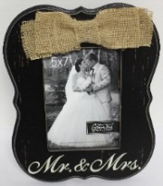 | $5 | 1 | Mr. & Mrs. picture frame with burlap bow  5”x7” photo
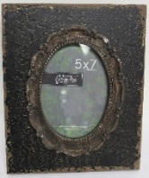 | $5 | 1 | Black and brown rustic picture frame  5”x7” photo
Furniture/Large Pieces
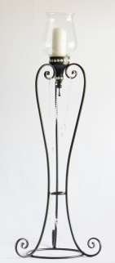 | $50 | 2 | Natalie  TBSAL  Tall black candle holder with added crystal gems, 50” tall
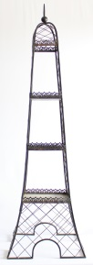 | $25 | 2 | Tower  FLP-TOWER  Antique black tower with 3 small shelves  54” tall
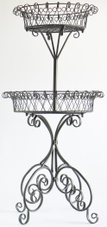 | $45 | 1 | Black Wire Basket  FLP-BWB  2 tiered black wire basket stand with scrolls  48” tall
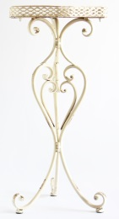 | $25 | 1 | Scroll side table  FLP-SST  Ivory side table with scroll design  30.5” tall
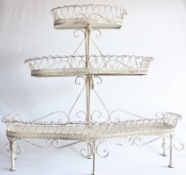 | $50 | 1 | Hepburn  FLP-HEPBURN  3 tier ivory cupcake stand holds at least 50 cupcakes  36”x33”
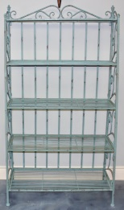 | $75 | 1 | Rustic Teal Shelf  FLP-RTS  Rustic teal shelf with 5 shelves  66”x36” at widest point
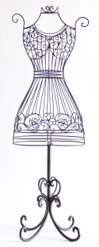 | $20 | 1 | Small Dress Form  FLP-SDF  Small black wire dress form  29” tall
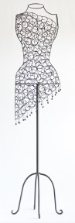 | $45 | 1 | Fiesta Dress Form  FLP-FDF  Large black wire dress form with fiesta dress look  59.5” tall
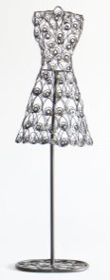 | $25 | 1 | Medium Swirl Dress Form  FLP-MSDF  Medium black wire dress form with swirls  39” tall
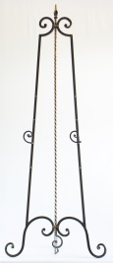 | $25 | 2 | Black and Brown Easel  FLP-BBE  Black and brown adjustable easel with scroll holders 60” tall
Tutu Skirts
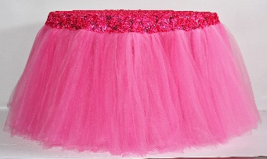 | $95 | 1 | Pink Tutu Skirt  TUTU-Pink  Pink tulle tutu skirt, fits a 42” round table included in rental
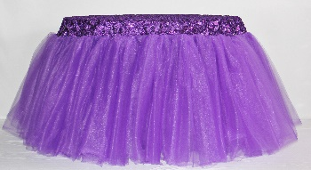 | $95 | 1 | Purple Tutu Skirt  TUTU-Purple  Purple tulle tutu skirt, fits a 42” round table included in rental
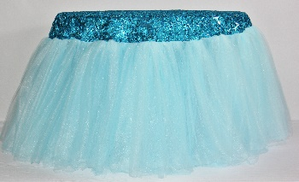 | $95 | 1 | Blue Tutu Skirt  TUTU-Blue  Blue tulle tutu skirt, fits a 42” round table included in rental
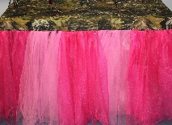 | $55 | 1 | Camo/Pink Tutu Skirt  TUTU-Camo  Pink and camo tulle tutu skirt, fits a 4x2 rectangular table included in rental
Chalkboards
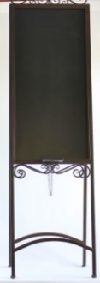 | $65 | 1 | Sasha  CB-SASHA  Brown double sided chalkboard, 70” tall,  chalkboard is 17”x37”
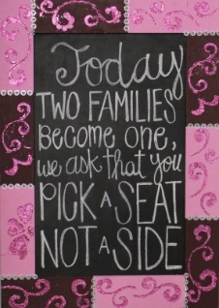 | $35 | 1 | Pink and Maroon Chalkboard  CB-PM  Pink and maroon chalkboard with glitter designs, 22”x31.5”  chalkboard is 15”x24.5”
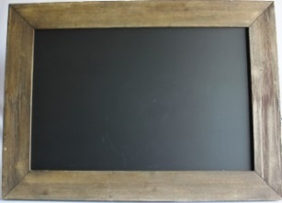 | $35 | 1 | Brown Chalkboard  CB-B  Light brown chalkboard, 27.5”x37.5”, chalkboard is 19.5”x29.5”
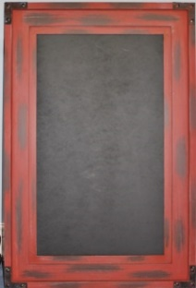 | $35 | 1 | Red Chalkboard  CB-R  Rustic red chalkboard, 24”x36”, chalkboard is 16”x28”
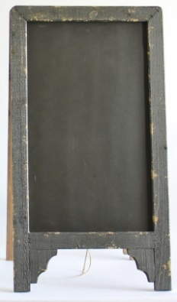 | $40 | 1 | Blue Double  Sided Chalkboard  CB-BD  Gray double sided chalkboard, 30.5” tall, chalkboard is 13.5”x23.5”
 |  | 1 | Cream Chalkboard  CB-C  Cream elegant chalkboard
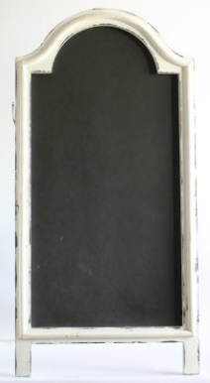 | $45 | 1 | White Double Sided Chalkboard  CB-WD  White double sided chalkboard, 40.5” tall, chalkboard is 34.5”x17”
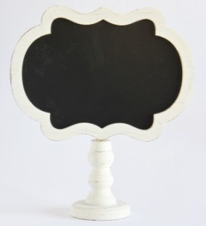 | $10 | 4 | Small Ivory Chalkboard  CB-SI  Small scroll chalkboard on ivory stand, 12.5” tall, chalkboard is 10”x6”
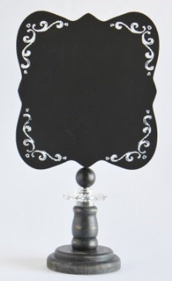 | $10 | 6 | Small Black Chalkboard  CB-SB  Small black chalkboard with scroll design on edges,  13.5” tall, chalkboard is 7”x8”
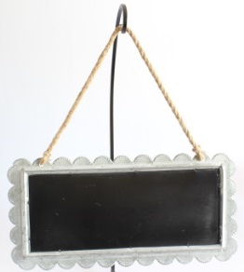 | $10 | 1 | Gray Hanging Chalkboard  CB-GH  Gray hanging chalkboard with rope hanger, chalkboard is 15.5”x6”
BB Serving Platters and Utensils
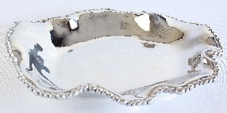 | $20 | 2 | Small Oval Platter  BB-SOP  Small silver oval shaped serving platter with pearl outline  12.5”x9.5”
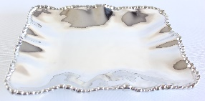 | $20 | 2 | Small Rectangular Platter  BB-SRP  Small silver rectangular shaped serving platter with pearl outline  9”x12.5”
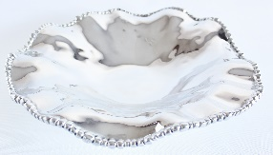 | $25 | 2 | Medium Round Platter  BB-MRP  Medium silver round serving platter with pearl outline  13.5” in diameter
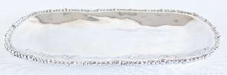 | $25 | 2 | Medium Oval Platter  BB-MOP  Medium silver oval serving platter with pearl outline  8.5”x16”
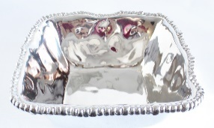 | $30 | 2 | Medium Square Bowl  BB-MSB  Medium silver square bowl with pearl outline  11.5”x11.5”x5”
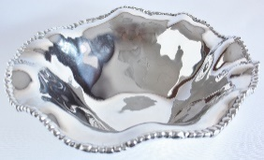 | $35 | 2 | Large Round Bowl  BB-LRB  Large silver round bowl with pearl outline  15”x15”x4.5”
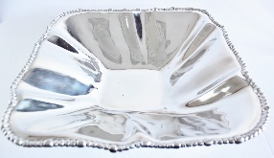 | $35 | 2 | Large Shallow Square Bowl  BB-LSSB  Large shallow silver square bowl with pearl outline  15”x15”x4”
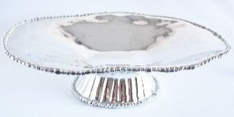 | $35 | 2 | Medium Oval Pedestal Platter  BB-MOPP  Medium silver oval pedestal platter with pearl outline  11.5”x18”x5”
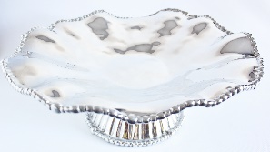 | $40 | 4 | Large Round Pedestal Platter  BB-LRPP  Large silver round pedestal platter with pearl outline  17” in diameter  5.5” tall
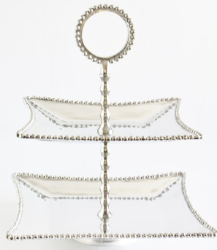 | $35 | 1 | Square 2 Tier Stand  BB-S2TS  Silver square 2 tiered stand with pearl outline, 18” tall, top tier 12”x12”, bottom tier 14”x14”
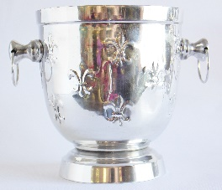 | $15 | 1 | Fleur De Lis Ice Bucket  BB-Fleur Silver ice bucket with fleur de lis stamped into the sides  8” in diameter  9” tall
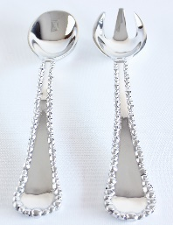 | $20 | 3 | Pearl Serving Utensils  BB-PSU Silver serving spoon and fork with pearl outline  11.5” long
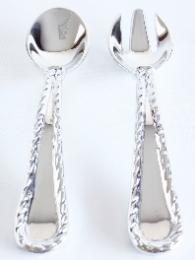 | $20 | 1 | Swirl Serving Utensils  BB-SSU Silver serving spoon and fork with swirl outline  11.5” long
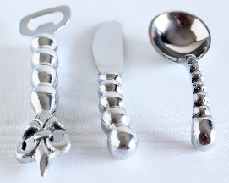 | $5  each | 1  2  2 | Bottle Opener (BB-BO)7” tall  Small Knife  (BB-SK) 6”  Deep Small Spoon (BB-DSS) 5”
Small Signs
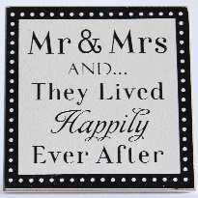 | $5 | 1 | S1  Mr. & Mrs. and…they lived happily ever after, stands by itself, 6”x6”
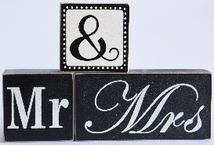 | $5 | 2 | S2  Mr. & Mrs., blocks, stands by itself, 6.5”x6.5”
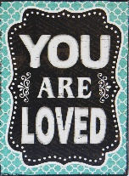 | $5 | 1 | S3  You are loved,  Stands by itself,  5.75”x7.75”
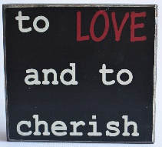 | $5 | 1 | S4  To love and to cherish, stands by itself, 7.5”x6”
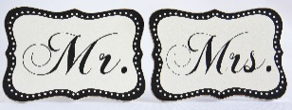 | $5 | 1 | S5  Mr./Mrs.  2 signs, comes as a set, stands by itself, 8”x6”
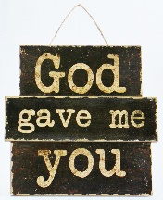 | $5 | 1 | S6  God gave me you, has wall hanger,  10”x10”
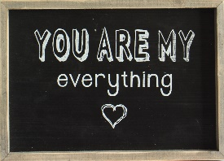 | $5 | 1 | S7  You are my everything, has wall hanger, 11.75”x8.25”
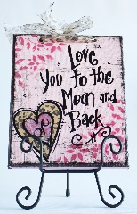 | $5 | 1 | S8  Love you to the moon and back, has wall hanger, easel not included  8”x10”
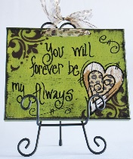 | $5 | 1 | S9  You will forever be my always, has wall hanger, easel not included 8”x10”
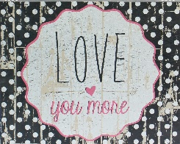 | $5 | 1 | S10  Love you more, stands by itself, 10”x8”
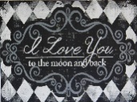  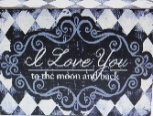 | $5 | 2 | S11  I love you to the moon and back, stands by itself, 2 color options, 8”x6”
 | $5 | 1 | S12  It doesn’t matter where you go in life, it’s who your with, stands by itself, 8”x6”
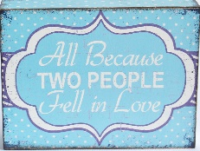 | $5 | 1 | S13  All because two people fell in love, stands by itself, 8”x6”
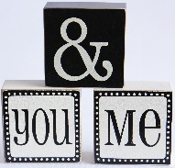 | $5 | 2 | S14  You & me, blocks, stands by itself, 11”x4”
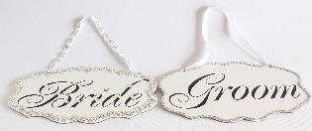 | $5 | 1 | S15  Bride/Groom, chair/hanging signs, 10”x6.5”
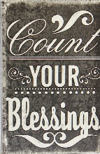 | $5 | 1 | S16  Count your blessings, box, stands by itself, 10.5”x6.5”x2”
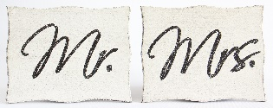 | $5 | 1 | S17  Mr./Mrs., comes as a set, has wall hanger, 10”x8”
 | $5 | 1 | S18  Where there is love there is life, stands by itself, 8”x6”
Medium Signs
 | $10 | 1 | M1  Love you more, has wall hanger,  11”x14”
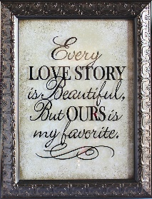 | $10 | 1 | M2  Every love story is beautiful, but ours is my favorite, has wall hanger, 13.75”x17.75”
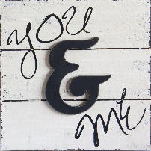 | $10 | 1 | M3  You & me,  has wall hanger, 12”x12”
 | $10 | 1 | M4  LOVE, has wall hanger, 15.75”x5.75”
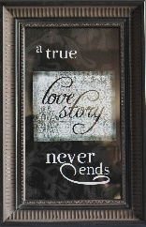 | $10 | 1 | M5  A true love story never ends, has wall hanger, 9.5”x14.5”
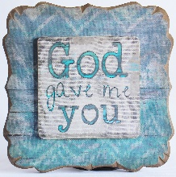 | $10 | 1 | M6  God gave me you, has wall hanger,  11”x11”
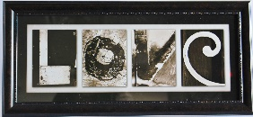 | $10 | 1 | M7  LOVE, has wall hanger, 22”x10”
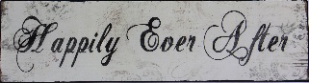 | $10 | 1 | M8  Happily ever after, has wall hanger, 19”x5”
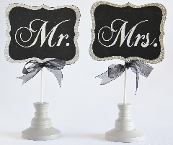 | $15 | 1 | M9  Mr./Mrs., 2 stands, comes as a set, 6.5”x12.5”
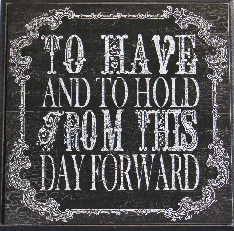 | $10 | 1 | M10  To have and to hold from this day forward, stands by itself, 12”x12”
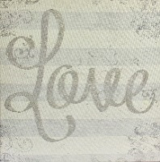 | $10 | 1 | M11  LOVE, has wall hanger,  16”x16”
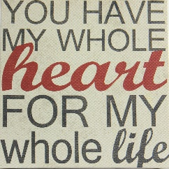 | $10 | 1 | M12  You have my whole heart for my whole life, stands by itself, 12”x12”
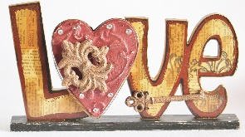 | $10 | 1 | M13  LOVE, stands by itself,  12.5”x7”
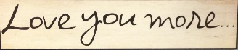 | $10 | 1 | M14  Love you more…, has wall hanger, 18”x4”
 | $10 | 1 | M15  Every love story is beautiful, but ours is my favorite, has wall hanger, 20”x8”
Large Signs
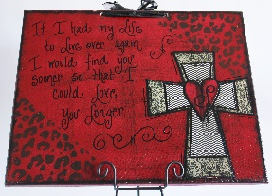 | $15 | 1 | L1  If I had my life to live over again I would find you sooner so I could love you longer, has wall hanger, easel not included  20”x16”
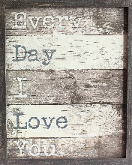 | $15 | 1 | L2  Every day I love you, has wall hanger, 17.25”x21.25”
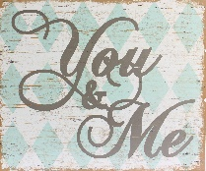 | $15 | 1 | L3  You & me, has wall hanger, 19”x16”
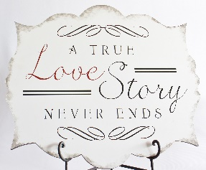 | $15 | 1 | L4  A true love story never ends, has wall hanger, easel not included 23.5”x20.5”
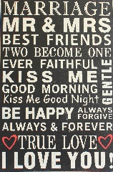 | $15 | 1 | L5  Marriage phrases, has wall hanger, 16”x24”
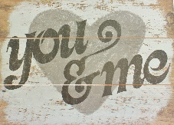 | $15 | 1 | L6  You and me, has wall hanger, 22”x16”
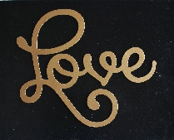 | $15 | 1 | L7  LOVE, has wall hanger,  20”x16”
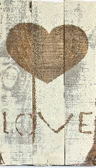 | $15 | 1 | L8  LOVE, has wall hanger,  9.5”x16”
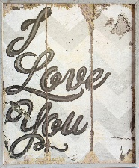 | $15 | 1 | L9  I love you, has wall hanger, 16.25”x19.5”
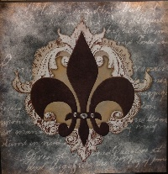 | $15 | 1 | L10  Fleur De Lis, has wall hanger, 20.5”x20.5”
XLarge Signs
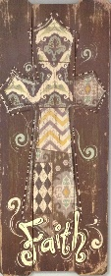 | $20 | 1 | XL1  FAITH (with cross, has wall hanger, 15.75”x39.25”
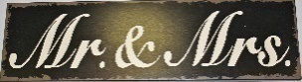 | $25 | 1 | XL2  Mr. & Mrs., has wall hanger, 42”x11.75”
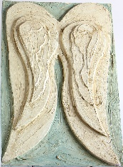 | $100 | 1 | XL3  Angel wings, has wall hanger, 24”x36”
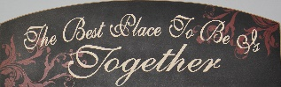 | $15 | 1 | XL4  The best place to be is together, has wall hanger, 36”x11.5”
 | $30 | 1 | XL5  I am my beloved’s and my beloved is mine, has wall hanger, 47”x15.5”
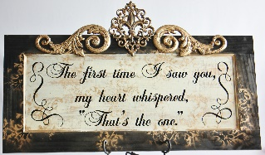 | $70 | 1 | XL6  The first time I saw you, my heart whispered that’s the one, has wall hanger, 40”x25”
Chandeliers
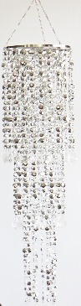 | $45 | 1 | Esme  C-ESME  Large silver multi diamond cut beaded chandelier, 3 tiers, 10” in diameter, 33.5” long
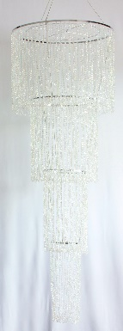 | $95 | 1 | Ava  C-AVA  4 tiered chandelier with iridescent beads, 24” in diameter, 72” long
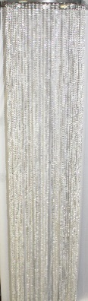 | $90 | 2 | Rainey  C-RAINEY  Iridescent beaded chandelier, 17” in diameter, 8 ft long
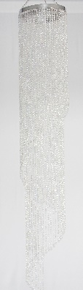 | $65 | 2 | Sassy  C-SASSY  Spiral iridescent beaded chandelier, 24" in diameter, 6 ft long
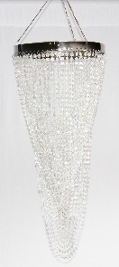 | $35 | 1 | Madison  C-MADISON  Twisted chandelier with iridescent beads, 9” in diameter, 21” long
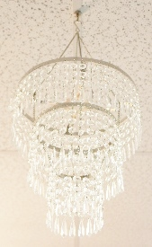 | $35 | 1 | Charlotte  C-CHARLOTTE  3 tier chandelier with large acrylic crystals, 10.5” in diameter, 11” long
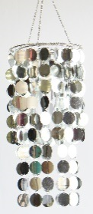 | $15 | 3 | Sylvie  C-SYLVIE  2 tier silver chandelier with round mirrored pieces, 8.5” in diameter, 18.5” long
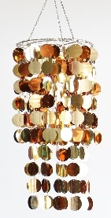 | $15 | 3 | Ginger  C-GINGER  2 tier gold chandelier with round mirrored pieces, 8.5” in diameter, 18.5” long
Additional Items
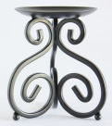 | $5 | 20 | Small Black Scroll Candleholder  AI-SBSC  Small black candleholder with scroll designs  5” tall
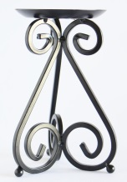 | $5 | 4 | Medium Black Scroll Candleholder  AI-MBSC  Medium black candleholder with scroll designs  7” tall
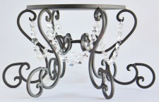 | $10 | 3 | Large Black Riser  AI-LBR  Large black riser with scroll design and hanging crystals  7.5” tall, 8.5” in diameter
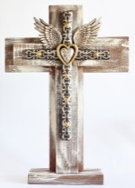 | $35 | 1 | Rustic Heart and Wings Cross  AI-RHWC  Rustic wooden cross with decorative cross, gold heart and wings  19.5”x27.5”
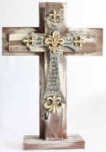 | $35 | 1 | Rustic Fleur De Lis Cross  AI-RFDLC  Rustic wooden cross with scripture engraved on fleur de lis cross  19.5”x27.5”
 |  |  | Turquoise Cross
 |  |  | Turquoise Cross
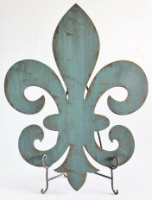 | $35 | 1 | Turquoise Fleur De Lis  AI-TFDL  Rustic wooden turquoise Fleur De Lis, easel not inluded  23”x30.5”
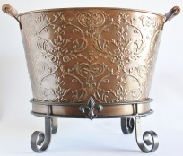 | $25 | 2 | Brown Scroll Design Bucket  AI-BSDB  Brown scroll design bucket with stand  12” tall, 12.5”x18.5” at opening of bucket
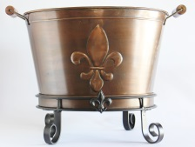 | $25 | 2 | Brown Fleur De Lis Bucket  AI-BFDLB  Brown fleur de lis bucket with stand  12” tall,  12.5”x18.5” at opening of bucket
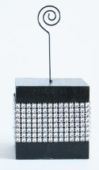 | $2 | 48 | Black Rhinestone Table Number Stand  AI-BRTNS  Black Rhinestone Table Number Stand,  6” tall
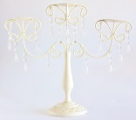 | $15 | 1 | Ivory Candleholder  AI-IC  Ivory candleholder with hanging jewels  17”x15”
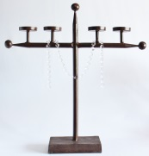 | $15 | 1 | Rustic Brown Candleholder  AI-RBC  Rustic Brown Candleholder,  21”x22”
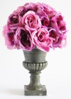 | $25 | 2 | Purple Flower Arrangement  AI-PuFA  Artificial purple flower arrangement in dark gray bling vase  13.5” tall
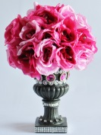 | $25 | 1 | Pink Flower Arrangement  AI-PiFA  Artificial pink flower arrangement in dark gray bling vase  13.5” tall
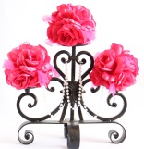 | $25 | 1 | Pink Pomander Arrangement  AI-PPA  Pink pomander flowers on iron scroll piece with added crystals  15”x17”
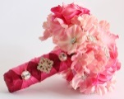  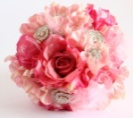 | $25 | 4 | Pink Bouquet with Bling  AI-PBB  Real touch artificial flowers in dark and light pink with added brooches and crystals and satin wrapped stem  7” wide
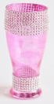 | $5 | 4 | Pink Pilsner Bouquet Holder  AI-PPBH  Pink pilsner glass bouquet holder with added crystals, 7” tall by 3” wide
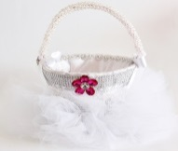 | $25 | 1 | White Tulle Flower Basket  AI-WTFB  White rhinestone flower girl basket with tutu skirt at bottom,  8” wide
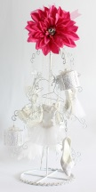 | $25 | 1 | Bridal Ornament Tree  AI-BOT  White iron stand with 11 bridal ornaments, 22” tall
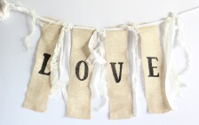 | $25 | 1 | Burlap and Lace LOVE Banner  AI-BLLOVE  Romantic burlap and lace LOVE banner  36” wide, 19” tall
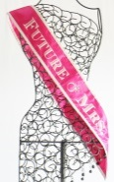 | $10 | 1 | Future MRS Sash  AI-MRS  Pink and white “Future Mrs” sash with bling on wedding ring,  28” long
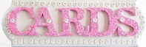 | $5 | 1 | CARDS Sign  AI-CARDS  Silver and pink CARDS sign with bling on edge  18.25”x6”
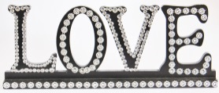 | $10 | 1 | LOVE Sign  AI-LOVE  Black LOVE sign with bling, stands by itself  18”x7”
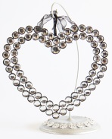 | $5 |  | Bling Heart  AI-BH  Rhinestone bling heart, open in middle  7” tall
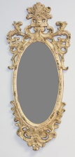 | $50 | 1 | Snow White Mirror  AI-SWM  Rustic ivory mirror with design around edges  41”x18”
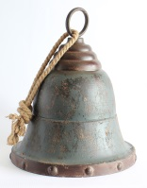 | $15 | 1 | Rustic Bell  AI-RB  Rustic blue and brown bell with rope hanger  16” tall
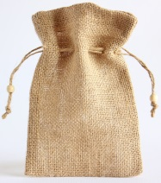 | $1  buy |  | Burlap Gift Bag  AI-BGB  Burlap gift bag with rope drawstring  5.5”x5”
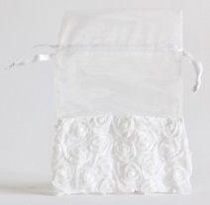 | $1  buy |  | White Rosette Organza Bags  AI-WROB  White organza bag with small white rosettes on bottom, has ribbon drawstring  5.5”x5.5”
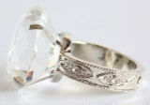  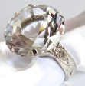  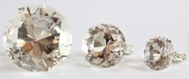 |  | 59  S  56  M  49  L  53  XL | Diamond Napkin Rings  Diamond ring napkin rings in 4 sizes, large rhinestone in center  AI-DNRS  Stone and ring are 1.25” wide  AI-DNRM  Stone and ring are 1.5” wide  AI-DNRL  Stone and ring are 1.75” wide  AI-DNRXL  Stone is 2.25” wide and ring is 2” wide

